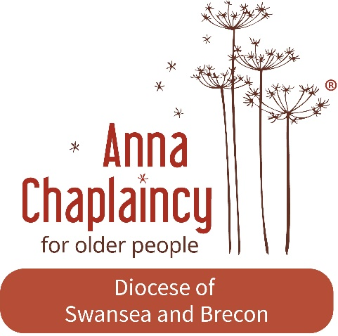

Person specification – Part time Anna Chaplain, Crickhowell and Llangynidr

Role Purpose
To provide Anna Chaplaincy to older people in Crickhowell and Llangynidr (see advert).
The role is for 8 hours per week for one year, with potential for further hours and development if / when able to secure funding.

The key area of responsibility initially is:
- To liaise and build relationships with established pastoral visitors / Anna Friend teams and local churches and effectively lead and support them in continuing Anna Chaplaincy Ministry.
- To develop local ecumenical links in Anna Chaplaincy ministry where possible encouraging Christians to share in this ministry.
- To liaise with Care Home staff regarding spiritual care and ministry to residents in Care Homes in Crickhowell and Llangynidr as appropriate.
- To keep a record of all aspects of the role so that evaluation of the role can be made
- To regularly report on Anna Chaplaincy progress

Essential skills
- Good communication skills
- Good interpersonal skills
- An understanding of some of the issues older people face
- Able to effectively lead, coordinate and support volunteers

Desirable skills
- IT literate, familiar with Microsoft Office and able to communicate by email.
- Prior experience of supporting older people (this could be in a personal or professional capacity)
Personal qualities:
- A heart and calling to Christian ministry with older people with a passion for reaching out to older people
- Ability to be Person-centred and non-judgemental
- Ability to demonstrate compassion, sensitivity and respect in your work
Training
The post holder needs to be willing to undertake the Anna Chaplaincy training course and any ongoing training necessary.
All reasonable training costs (including the Anna Chaplaincy training course) will be covered.
The post holder will be commissioned into the St Catwg Minsitry Area and employed through ‘Faith in families’ for pay role and Human Resources (HR) support.
The post is subject to a clear Enhanced Disclosure (DBS check) and satisfactory references.

The funds for this position have been generously donated by the Gibbs Trust – a registered charity that supports the innovative undertakings by Methodist churches and organisations, other Christian Causes and a wider category in the fields of creative arts, education, social and international concern.

