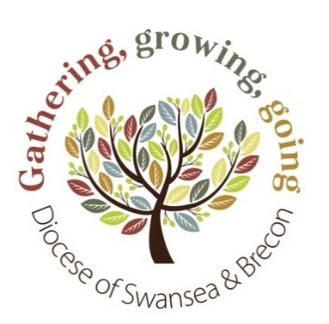
Diocesan Funding Committee
Grant Application Form
Small Grants: £501-£1,000

The Diocesan Funding Committee (DFC) manages applications for the Mission Fund. The fund’s criteria can be found in the supporting document ‘Funding Priorities and Practicalities’
We advise you to read this document thoroughly prior to completing this application form.

You can fill in this form electronically. If you have any questions about how to fill in the form or about whether your project is eligible, please get in touch (contact details at the end of the form).

IMPORTANT: If you are filling the form in by hand and need to use additional sheets, please make sure that the name of the Project is printed clearly at the top of every page.

SECTION 1

Project Name:
Applicant:
(Parish, Benefice, Ministry Area)
Date of Application:
Proposed Start Date:
Proposed Finish Date:

Grant Amount Applied for:

SECTION 2 – Project Contact

Name:
Address:
Postcode:
Tel No:
Email Address:

SECTION 3 - The Project

- Describe what you are aiming to do with this project. Please include all the activities you are requesting to be funded:

- Select one or more of the categories below which suit the purpose of your project:
Worship / Prayer Groups |  | Messy Church |  | Ministry Area Development
Specific Individual Training |  | Youth Work |  | Diocesan Events / Materials
Special Events |  | Faith in Families Projects |  | Church Building development
Social Media & Publications |  | Clubs |  | Outreach projects
Offices / Staffing |  | Collaborative Ministry |  | Community Engagement

- How will your project transform the lives of the people in your communities or help further the development of your Ministry Area?

- Describe briefly how you think your project reflects the Diocesan Vision or Vision 2020?

- What is the estimated number of people you expect to benefit from this project?

- How long will the project last?
Please note that grants can only be committed for one year and must be spent within one year of receipt. For ongoing projects that require funding after the initial grant, the applicant must demonstrate a fundraising sustainability plan. Whilst further applications would be welcomed, there can be no guarantee that they would be successful.

- What specific goals do you have and how you will know if you have achieved them?
Specific Goals: | Achievements:

SECTION 4 – Management of your Project

- Who will oversee the Project?

- What support is there for the project from other local churches and/or local community?

- It is a condition of any Diocesan grant that you will be required to complete a project report form within ONE MONTH of the project funding ending
Please tick the box to confirm that you have read and understood this condition

SECTION 5 – Finance

- Resources required – Please list your TOTAL ESTIMATED PROJECT COSTS
Item |  | Estimated cost
Total |  | £
- How much do you have already? |  | £
- How much are you applying for in this application? (£501-£1,000) |  | £
- Any monies awarded will be transferred by BACS payment.
Please provide details of the receiving bank account:
Name of Account:
Name of Bank:
Sort Code:
Account Number:

SECTION 6 – Supporting Documents

Please tick the box below to confirm that you have provided the required supporting documents with your application:
A copy of the PCC minute agreeing this project

Signed: Name: Project Contact

Signed: Name: Ministry Area Leader

Signed: Name: Area Dean

Comments from Ministry Area Leader
Please provide any additional information regarding Parish/Ministry Area background that you feel will be useful for this application

Date:

Please return, by email to: diocese.swanbrec@churchinwales.org.uk

or by post to: Diocesan Funding Committee
Swansea and Brecon Diocesan Centre
Cathedral Close
Brecon
Powys
LD3 9DP

If you have enquiries about this form or need clarification, please contact the Diocesan Centre on 01874 623716 or via the email address above.

